7  June | Morning Star  Presbyterian Church
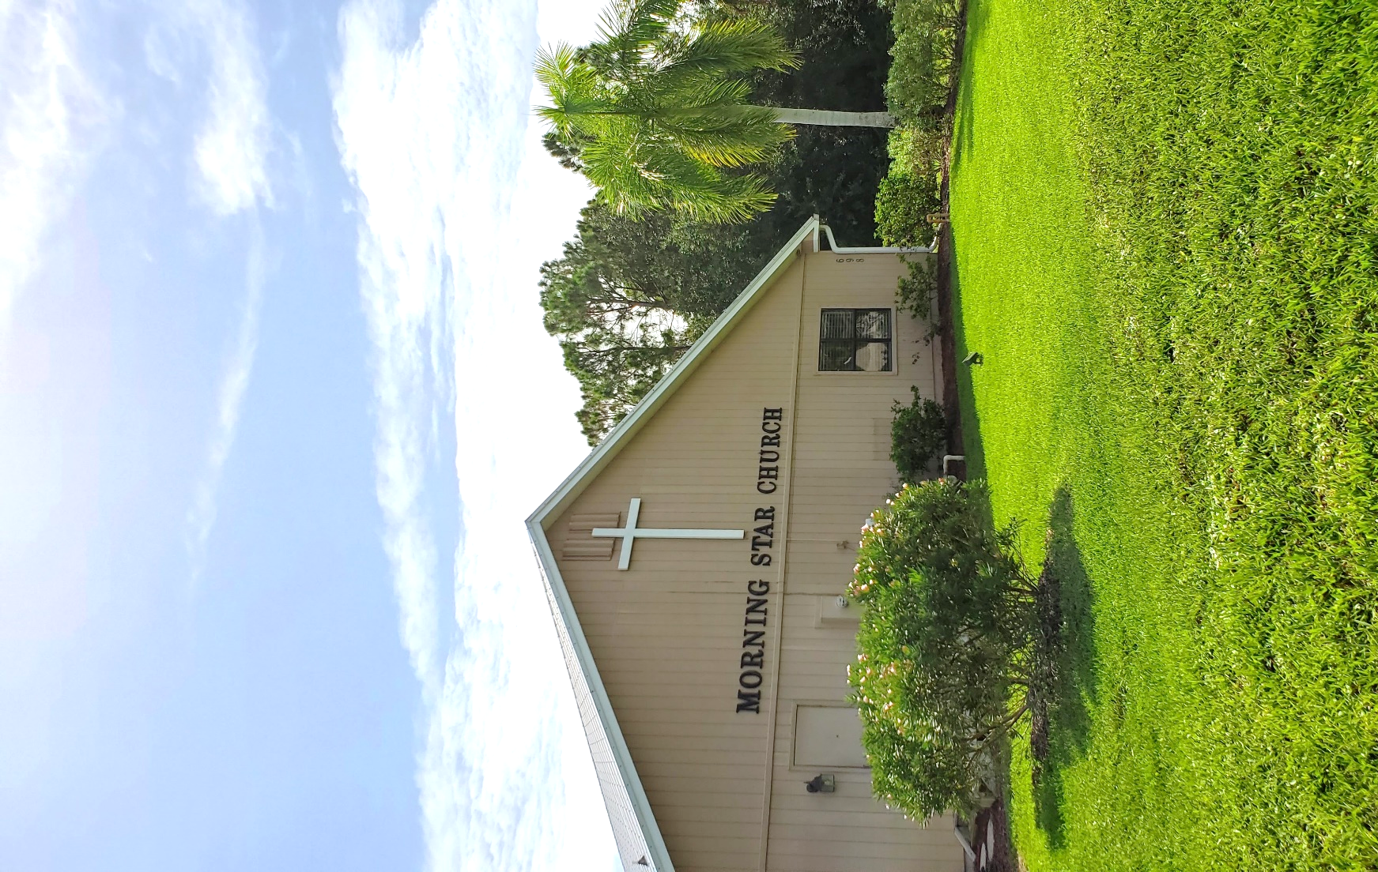

Our Church Vision:
As the new day approaches,
we want Christ's beauty, love, and holiness to shine through us
in 3 dimensions: worship, community, and gospel service.

Our Mission:
To shine Christ’s beauty, love, and holiness
as far as our beams extend.
Our Denomination:
Morning Star is a part of the Associate Reformed Presbyterian (ARP) Church, which was established in America in 1782, soon after the
American Revolution, with roots extending back to Scotland.
Jesus is the “bright Morning Star” - Revelation 22:16

Service Times  Children’s Sunday School – 9:00 am  Adult Sunday School – 9:00 am  Sunday Morning Worship – 10:00 am  Tuesday MS/HS Chapel – 10:00am  Wednesday Evening Study – 6:30 pm  Friday Morning Study – 9:15 am  Leadership Team  Pastor: Trevor Raborn  Elders: Mark Shaver  Brian Bogart  Deacons: Robert Shaver  David Wray | Contact  Phone:  772-562-6009  Email:  office@morningstarvero.org  pastortrevor@morningstarvero.org  prayforthis@morningstarvero.org  Media:  MorningStarVero.org  Follow us @MorningStarVero  Address:  698 Timber Ridge Trail SW, VB, FL 32962

Children of all ages are welcome to stay in the sanctuary with you or be signed in to the Nursery or the Children’s Corner.
Sign-in sheets are on the table at the back of the sanctuary.
Sunday Student Ministry

Children’s Sunday School
Available to Elementary and Middle School kids every Sunday at 9am, before the service. A solid Biblical teaching is given with props and helpful learning tools for practical life application.

Nursery (6 months - 3 years old)
Available during the 10am church service (optional). Volunteers are experienced, background checked, and available to watch your kids.

Children’s Corner (PreK- 5th Grade)
Kids are invited to follow along with the sermon in the back fellowship hall with a children’s Bible. We have volunteer staff who will guide them as they listen to the sermon. It’s a great way to give them a chance to ask questions about things they don’t understand. Your kids will join back with your family for the final worship song and benediction.

Verse of the Week

Exodus 17:16
“saying, “A hand upon the throne of the Lord! The Lord will have war with Amalek from generation to generation.”

Before Service: Meet in Prayer Room
(Open to all, from 9:45-9:55am)

Announcements

Call To Worship
Pastor: ¹ Shout for joy to God, all the earth;
²sing the glory of his name;
give to him glorious praise!
People: ³ Say to God, “How awesome are your deeds!
So great is your power that your enemies come cringing to you.
Together: ⁴ All the earth worships you
and sings praises to you;
they sing praises to your name.”
Psalm 66:1-4

Opening Hymn: “Come People of the Risen King”
Invocation, Confession, and Assurance of Pardon
Hymn of Response: “Good to Me” *
Reading of the Word
Philippians 2:10
‬Pastoral Prayer

Offertory Hymns**
“I Sing The Mighty Power of God”
“Praise is Rising”
Children’s Sermon
The Covenant Of Grace In The Preaching of the Word
By Pastor Craig Starley
Exodus 17:9-16
"The Battle Belongs to the Lord”
Closing Hymn: “The Battle Belongs To The Lord” *
Blessing and Refreshments *

* if you are able, please stand
** The Offering Plate is available at the front, left of the sanctuary
for tithes to be placed in it before and after service.
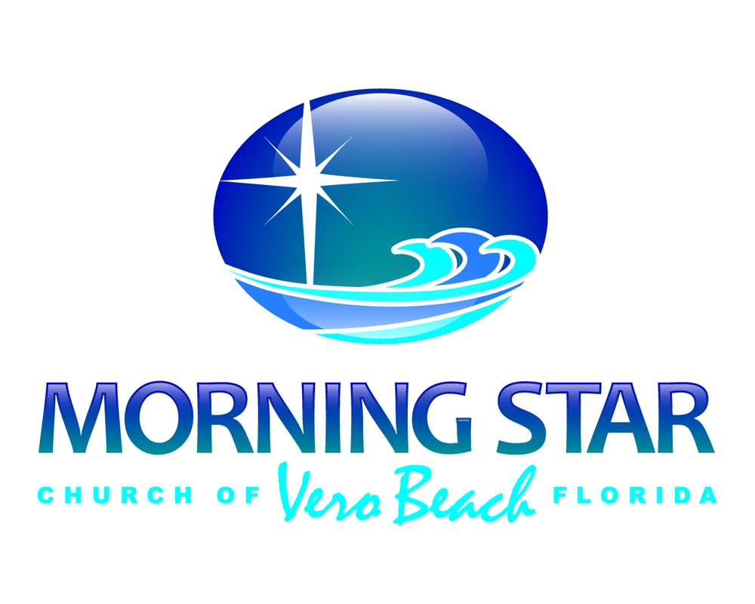
Announcements

TableTalk Magazines for the month of June are available!
Walking Club was rained out last week and postponed until this Tuesday, join us at Greenway Lagoon!
- Next Meeting: Tuesday, June 9th at 7pm
Wednesday Evening Bible Study – You are encouraged to join us at the Church building for a new study on Ruth. Morning Star would love to see everyone there!
- Next Meeting: Wednesday, June 10th at 7pm
The Scholar Evangelist – We will host a meet up at the church for the screening of this free event, with lunch provided.
- Sign up for the event at EvangelizeToday.info/ScholarEvangelist
- Email the office if you would like to RSVP for lunch at the church: office@morningstarvero.org
- Event Date: Tuesday, June 16th from 2-4pm

Guest Preacher: Craig Starley,
M.Div Student from Knox Theological Seminary

Bio: We welcome Craig Starley as our guest preacher for this Sunday’s Worship Service. Craig is a student of Knox Theological Seminary, currently serves as the Director of the Men’s Ministry at Coral Ridge Presbyterian Church and Father to 4 wonderful kids: Abigail 21, Joshua 20, Elijah 18, Elizabeth 16. Raised in a Jewish family, Craig came to know the Lord almost 30 year ago and God has placed it on his heart to be involved in Men’s Discipleship. He currently works as a TV Producer and is looking forward to God’s call in ministry.

Flowers Dedicated by Paula Bogart
for her daughter Erin Belle
Sermon Notes
________________________________________________________________________________________________________________________________________________________________________________________________________________________________________________________________________________________________________________________________________________________________________________________________________________________________________________________________________________________________________________________________________________________________________________________________
____________________________________________________________________________________________________________________________________________________________________________________________________________________________________________________________________________________________________________________________________
Book Recommendation:
Knowing God by Name
By Kay Arthur
Names of God
By Nathan Stone

Sermon Sketches

Weekly Events
TUESDAYS
Middle/High School Chapel meets at 10am on Zoom for a message on the Parables of Jesus. Email Pastor Trevor for Link

WEDNESDAYS
Morning Prayer Time at 9AM at the church or via Zoom
The Evening Bible Study will meet at the church and FB Live at 7PM to study the book of Ruth

FRIDAYS
Morning Bible Study led by Dennis Rupert will meet at Karen Shaefers House and streamed on Zoom at 9:15am to study Revelation
STARS Youth Group meets weekly at 7pm at the church

Special Events For The Month Of June
SUN | MON | TUE | WED | THUR | FRI | SAT
31  Fifth Sunday Feast | 1 | 2 | 3  WeAreVero Luncheon | 4 | 5 | 6  Men’s Morning
7 | 8 | 9  Walking Group | 10  WeAreVero Luncheon | 11 | 12 | 13
14 | 15 | 16  Workshop  & Walking Group | 17  WeAreVero Luncheon | 18 | 19 | 20  Men’s Morning & Book Study
21 | 22 | 23 | 24  WeAreVero Luncheon | 25 | 26  TBG  Graduation | 27
28  Lord’s Supper | 29 | 30

